Report: Algorithm Design

Main():

The main function contains a variable with directory of image folder, it calls the *face_recognise(dir)* function and control is then passed on to *face_recognise(dir)*

Face_recognise() function:

**Training a model:**

Trainingis done using *SVM* classifier. The *face_recognise(dir)* function implemented, takes in the directory where images are stored as *name.jpg*. OS module is used to traverse between images in the image directory. A variable *Person_img* takes the image array using *For* loop. Image is loaded as a NumPy array in RGB mode using *load_image_file()* function which depends on *PIL* library.

An encoding vector is generated for each image. Each encoding is stored in encoding array and each *name.jpg* is stored in name array.

**Encoding**: An encoding is a vector of 128 integer values. Encoding an image generated a mesh of 128 key points in a face this is done by calculating the *Histogram of Oriented Gradients* (HOG). The points in the below image corresponds to integer values in the encoding vector of a face:

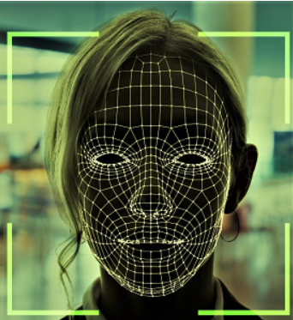

After the encodings are generated, The *SVM* classifier runs on all the encodings generated and produces multi-dimensional hyperplanes based on number of faces for classification.

**SVM classifier**:

A Support Vector Machine (SVM) is a *supervised machine learning algorithm* that can be employed for both classification and regression purposes. SVMs are based on the idea of finding a hyperplane that best divides a dataset into two classes. An example is shown below.

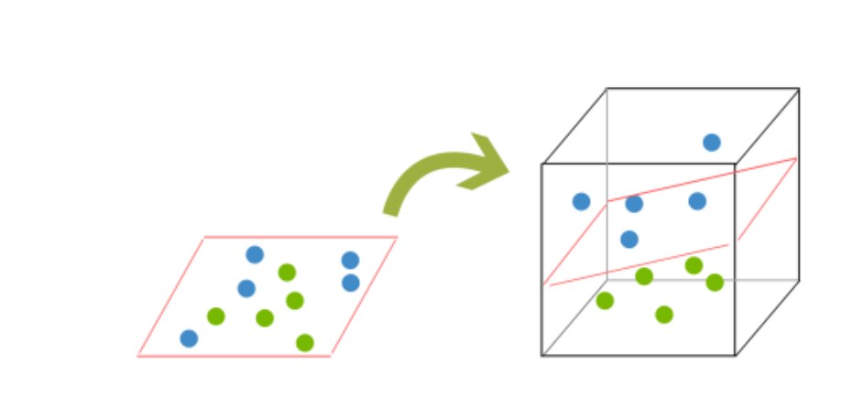

**Real time detection:**

Using *OpenCV* real time feed from primary camera is taken. Faces in each frame of the video are recognized and their encodings are generated. This encoding is then matched to one of the pre-trained encodings and the closest encoding’s label is assigned to the real time face.

All the faces recognized in real time are stored in *present* array.

**Saving the data:**

A text file *test.txt* is opened in ‘write’ mode and all the names in the *present* array are stored in this file in *NumPy* array format. This can be later retrieved to find out names of students present in the class.